coding_.master•Follow

<https://www.instagram.com/p/CH7C4L5A3g5/?igshid=10t89zrvx0sth>

23. November 2020

big_it_jobs•Seuraa

<https://www.instagram.com/p/CH-5jWtoBVY/?igshid=13gcbw9p59x3z>

24. November 2020

big_it_jobs•Seuraa

<https://www.instagram.com/p/CIDCBPMAzrW/?igshid=1dibhuh4usbgk>

26. November 2020

big_it_jobs•Seuraa

<https://www.instagram.com/p/CIDCBPMAzrW/?igshid=1gtxu7hf8r08z>

26. November 2020

programmerplus•Follow

<https://www.instagram.com/p/CIIxhVzAz-g/?igshid=m9uyepozgf9i>

28. November 2020

big_it_jobs•Seuraa

<https://www.instagram.com/p/CIKjyC9AxMo/?igshid=7lj9bkz931oe>

29. November 2020

coding_.master•Follow

<https://www.instagram.com/p/CILFNLbA5aP/?igshid=kpn5rja62d3d>

29. November 2010

jscripters•Follow

<https://www.instagram.com/p/CIKXrubAiBO/?igshid=5gh77fluprgm> 7 JavaScript Functions

29. November 2020

developerspace•Seuraa

4. December 2020

<https://www.instagram.com/p/CIXoxpjgC93/?igshid=18j8qsh4pii4z> Big HTML Cheatsheet

thecodecrumb•Seuraa

6. December 2020

<https://www.instagram.com/p/CIdAhiWgw7J/?igshid=1zjg3u89mj0g> Linux , Linux Commands Cheatsheet

coderalbum•Seuraa

6. December 2020

<https://www.instagram.com/p/CIdggnUARUH/?igshid=85ue2uhmruzd> Top JavaScript frameworks to learn

big_it_jobs•Seuraa

<https://www.instagram.com/p/CIcgV10A6Rf/?igshid=nzeglzb7xr9q>

8. December 2020

webdevelopment24x7•Follow

<https://instagram.com/coding_.master?igshid=aj253e4ti628> 1 JS CSS

<https://instagram.com/programmerplus?igshid=13qeqqkbig39v> 1 JS CSS Python React Vue

<https://instagram.com/jscripters?igshid=144t7vipeejoy> 1 JS JavaScript snippets memes

developerslab•Seuraa

@javascript-days

5. March 2021

developerslab 👋

JavaScript Date… more

Show all 16 comments

5. March 2021

codergallery•Follow

25. April 2021

<https://www.instagram.com/p/COGc6FNJJbN/?igshid=10avgqu3yvnks> Full Stack Gap

pythonbasics•Seuraa

python3learning•Seuraa

thecodingroom•Follow

<https://www.instagram.com/p/CITIai8Du9L/?igshid=e71pcm3iw6zt>

codes.learning•Seuraa

<https://www.instagram.com/p/CIHtxpZA8cz/?igshid=1vq1w466cj7xb>

codes.learning•Seuraa

<https://www.instagram.com/p/CITRUTogmtK/?igshid=6cxz4t288hpz>

itss_python•Seuraa

<https://www.instagram.com/p/CH-0K9Fg2Ov/?igshid=t0bcvgwumuai>

big_it_jobs•Seuraa

<https://www.instagram.com/p/CH-5jWtoBVY/?igshid=13gcbw9p59x3z>

24. marraskuuta 2020

big_it_jobs•Seuraa

26. marraskuuta 2020

<https://www.instagram.com/p/CIDCBPMAzrW/?igshid=1dibhuh4usbgk> Popular Database

big_it_jobs•Seuraa

<https://www.instagram.com/p/CIDCBPMAzrW/?igshid=1gtxu7hf8r08z>

26. marraskuuta 2020

big_it_jobs•Seuraa

<https://www.instagram.com/p/CIKjyC9AxMo/?igshid=7lj9bkz931oe>

29.marraskuuta 2020

developerspace•Seuraa

4. joulukuuta 2020

<https://www.instagram.com/p/CIXoxpjgC93/?igshid=18j8qsh4pii4z> Big HTML Cheatsheet

thecodecrumb•Seuraa

6. joulukuuta 2020

<https://www.instagram.com/p/CIdAhiWgw7J/?igshid=1zjg3u89mj0g> Linux Commands , Cheatsheets

coderalbum•Seuraa

6. joulukuuta 2020

<https://www.instagram.com/p/CIdggnUARUH/?igshid=85ue2uhmruzd> **Top** JavaScript frameworks **to learn**

Each **JS** framework is a tool that makes working with **JS** much easier and smoother:

**React** was created by Facebook. **Angular** is an open-source and secure typescript based on the framework by Google and is used to build client-side single-page web apps. **Vue.js** is like Angular, an open-source lightweight front end framework, and is used to build creative user interfaces and high-performance single-page web apps. With the user's minimum efforts Vuejs is launched.

**Ember.js** is meant to create single-page web apps for enterprises. Unlikely React, Angular and Vue.js, Emberjs is based on the Model-View-View-Model (MVVM) architecture pattern.

Backbone.js

Ember.js

Gatsby.js

Next.js

Angular.js

React, Reactjs

Vue.js

big_it_jobs•Seuraa

8.joulukuuta 2020

<https://www.instagram.com/p/CIcgV10A6Rf/?igshid=nzeglzb7xr9q> Most Loved DevOps , Platforms

coding.batch•Seuraa

<https://github.com/smthari>

<https://t.me/coding_batch>

<https://linktr.ee/coding.batch>

coding.batch•Seuraa

<https://www.instagram.com/p/CII4AhGIm70/?igshid=1l1vr3iwda32k>

thecodingroom•Follow

Toronto

Do you want to become a **Developer**

Stay focused on one language at a time. Don't tip first into JavaScript, then a bit of Python and then try Java. Learn one language at one a time. You must be consistent. Practice will make perfect. Practice everyday. Learn something new.

Web Developer or Entrepreneur?

Must be passionate. If you love developing and your answer is 'Yes', there will be no problem. If the answer is 'No', then don't become a Developer.

Step outside of the comfort zone. Sometimes it can be difficult to take on new projects. Your community helps and Google too.

Tools I use everyday as a **Web** Developer:

Notion

Vscode

Slack

Chrome

Github.

Full-Stack Developer - Learn To Code, Science, Technology and Planning, Forever coding 🤞

🤗Learn something new on quality🤗

Python•JavaScript•Ruby

Linux

Data Science•AI•ML!

codes.learning

A programming laptop must have these things

RAM

Minimum: 4 GB

PROCESSOR

Minimum: i3

GRAPHIC CARD

Minimum: NIL

VS CODE

Version: 1.51

INTERNET

Type: Wifi or Ethernet

ARCHITECTURE

Type: 64 BIT

codes.learning

codes.learning•Seuraa

Popular websites & Youtube channels to learn programming free

POPULAR WEBSITES & YOUTUBE CHANNELS TO LEARN PROGRAMMING FREE

Websites

Youtube

1. Copyassignment.com
2. Geeksforgeeks.com
3. Javapoint.com
4. Tutorialspoint.com
5. Studypoint.com

Youtube

1. Tech21
2. Treehouse
3. Learncode•academy
4. Derek Banas!
5. Programmingknowledge

Also visit our website➡️copyassignment.com to learn Python and for small projects source codes 🧠💻

Comment your views on the post. Follow @codes.learning for more information and programming 🧠💻

Turn on story and post notifications for good times 😀💯

Thank you for your support😀❤️

itss_python•Seuraa

World of AI, Python, Java All in One.

Hacking, AI 👽with Python

Different It Sectors

SOFTWARE ENGINEER

Java

C++

Python

WEB DEVELOPMENT

HTML

JavaScript

CSS

CYBER SECURITY

Linux

Social engineering

Networking

DIGITAL MARKETING

Google Adwords

Google Adsense

Search Engine Optimization (SEO)

codes.learning•Seuraa

itss_python•Seuraa

pythonbasics•Seuraa

python3learning•Seuraa

python3learning

@codehub.py

@codehub.py

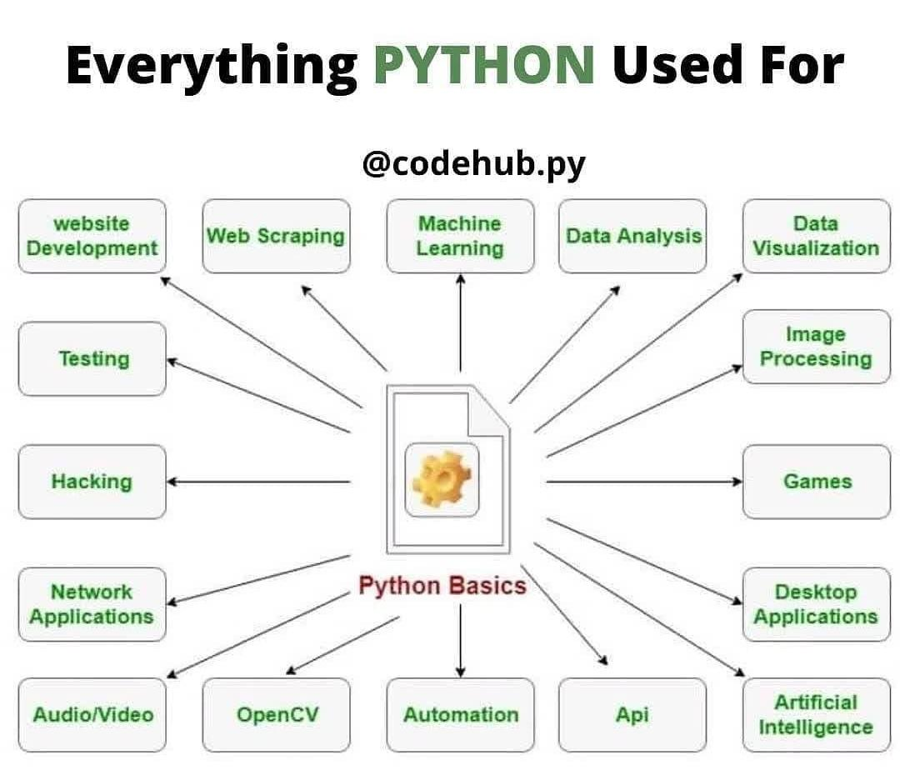

python3learning

Science, Technology and Planning



Everything PYTHON Used For

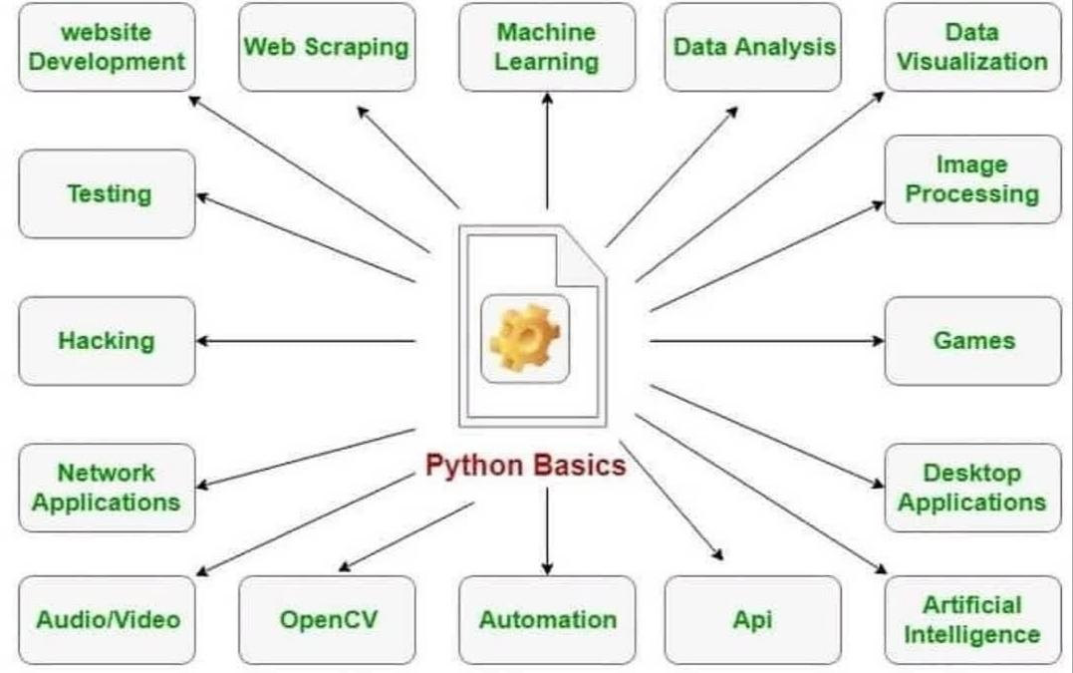

python3learning Strong Your Basics of Python 🔥🔥🔥…

.

Follow @python3learning For more Python Programming contents 🔥

.

For more knowledge/information watch our story 🤠

.

Visit our website inprogrammer.com to get source codes of projects link in bio ⚡👍..

.

Save The Post For Future use 🧠 and Tag it or Share It To Your Programmer Buddy So He/She Learn It Too...😊

.

.

.

.

.

Link list

Python is🔥